

GUIDELINES FOR THE FCO FILE

Food consumption occasions (FCO) (Common)

This file provides a list of the following 11 possible food consumption occasions.
CD FCO LABEL # LABEL ON SCRN
01 Before Breakfast (Wake Up) 0 Wake Up
02 Breakfast 0 Breakfast
03 During the Morning 1 Snack
04 Before Lunch (Aperitif) 0 Aperitif
05 Lunch 0 Lunch
06 After Lunch 0 Digestif
07 During Afternoon 1 Snack
08 Before Dinner (Aperitif) 0 Aperitif
09 Dinner 0 Dinner
10 After Dinner (Digestif) 0 Digestif
11 During the Evening/At Night 1 At night

The first column above indicates the code for a given FCO. This code is not to be changed. In the second column is the FCO label, which may need to be translated into the country language. It can be a maximum of 100 characters. The third column above indicates how many times in your interview you may use a certain occasion. ‘0’ indicates that you can use this occasion only once and ‘1’ indicates that you can use this occasion more than one time during the interview (e.g. ‘breakfast’ can be selected once whereas ‘during the morning’ may be chosen several times). The fourth column is for a short FCO label, which can be a maximum of 50 characters.

Actions:
- check if the provided list of FCO is suitable for the project
- define if a FCO may be chosen several times (0/1). Usually, the main FCOs of the day such as breakfast, lunch and dinner should have “0”.
- define the main FCOs which will appear on the final control screen (see image 4)
- once an agreement has been reached, translate the two label columns into your national language(s) and keep the codes (note: the description has got a maximum of 50 characters). Use the ‘insert’ key to maintain the positions of the columns in the document.

Use the ‘insert’ key when adding the translations in order to maintain the positions of other columns.

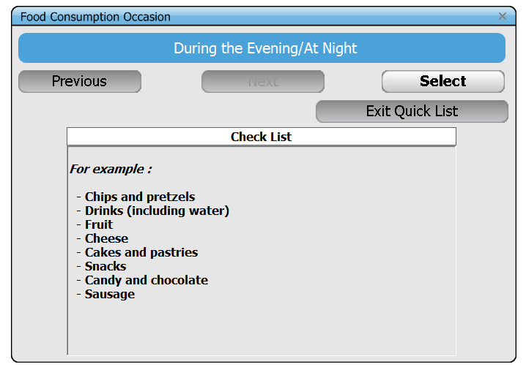
Figure 1: Print screen of the food consumption occasion screen in GloboDiet during the quick list step.

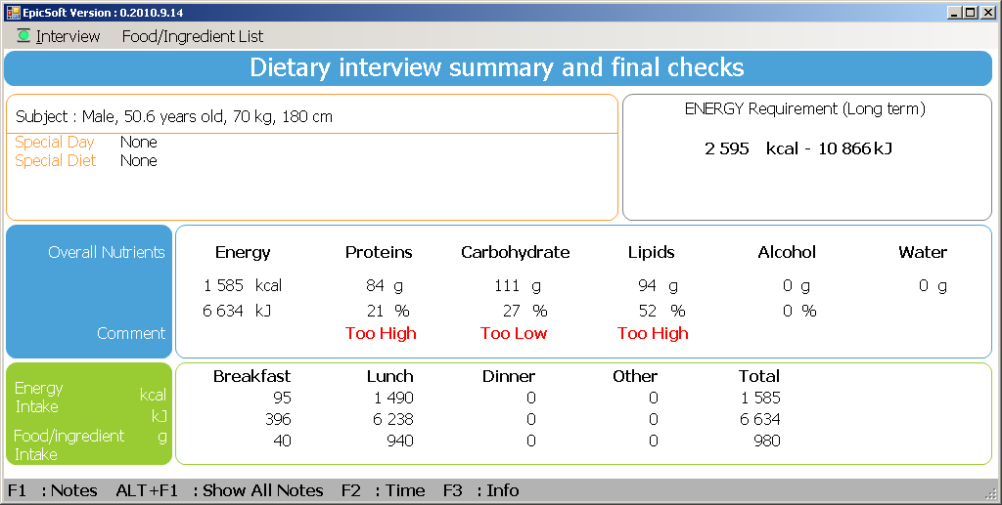
Figure 2: Example of main food consumption occasions appearing on the final control screen

